





There are 506 rows of suburbs and 14 columns of predictors.



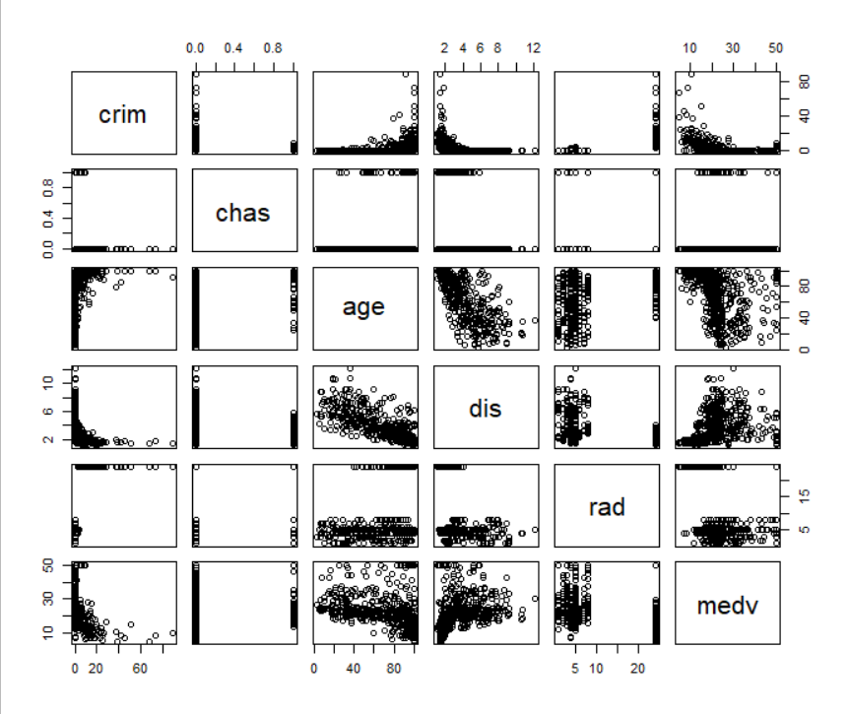

crim(per capita crime rate by town) seems to have positive relationship with age(proportion of owner-occupied units built prior to 1940), negative relationship with dis(weighted mean of distances to five Boston employment centres) and negative relationship with medv(median value of owner-occupied homes in \$1000s).

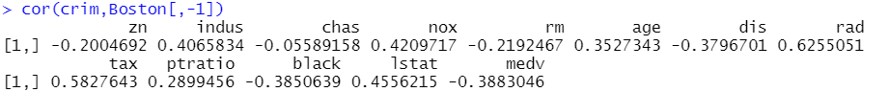

We can see that,

**chas** (Charles River dummy variable (= 1 if tract bounds river; 0 otherwise)) has moderate negative relationship with **crim**(per capita crime rate by town).

**rad**(index of accessibility to radial highways) has moderate positive relationship with **crim**(per capita crime rate by town).

**tax**(full-value property-tax rate per \$10,000) has moderate positive relationship with **crim**(per capita crime rate by town).



Here we used **mean+2*sd** measure (higher than 95% of the suburbs)

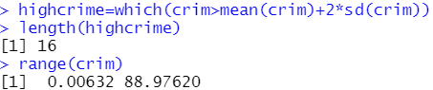

16 suburbs appear to have high crime rates. The range is too wide.

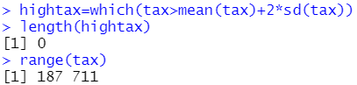

There are no suburbs with high tax rates. The range is narrower than crime rate.

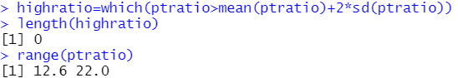

There are no suburbs with high pupil-teacher ratio. The range is quite narrow.

1. Here, we have to find, which people have **chas** value “1”



35 suburbs bound the Charles river.





median pupil-teacher ratio in this dataset is 19.05.



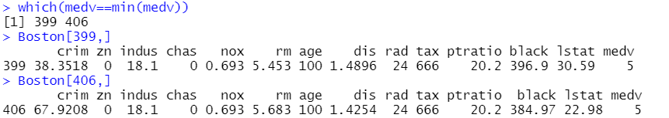

399th and 406th suburb of Boston has the lowest median value of owner-occupied homes.



